**BlazeMeter** markets a commercial, self-service [load testing](https://en.wikipedia.org/wiki/Load_testing) [platform as a service](https://en.wikipedia.org/wiki/Platform_as_a_service) (PaaS), which is compatible with [open-source](https://en.wikipedia.org/wiki/Open-source) [Apache JMeter](https://en.wikipedia.org/wiki/Apache_JMeter), the performance testing framework from the [Apache Software Foundation](https://en.wikipedia.org/wiki/Apache_Software_Foundation) BlazeMeter was founded in 2011, and was acquired by CA Technologies in 2016.

**BlazeMeter Setup:**

First we need to have a BlazeMeter Account for recording our scripts

Login to the <https://www.blazemeter.com/> and create one account .

1. Blazemeter Scripts can be recorded by two ways:
2. Going to the <https://www.blazemeter.com/> 🡪 create Test

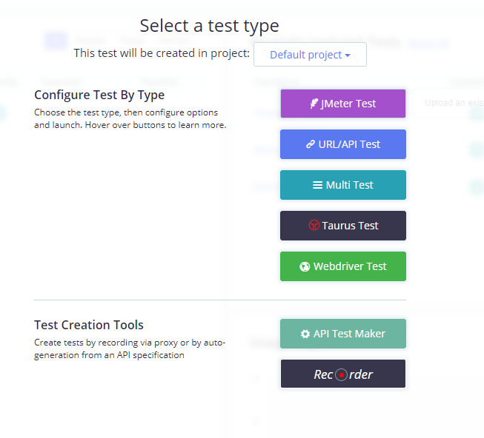

Select the recorder option .

1. Download the “Blazemeter” chrome extension plugin

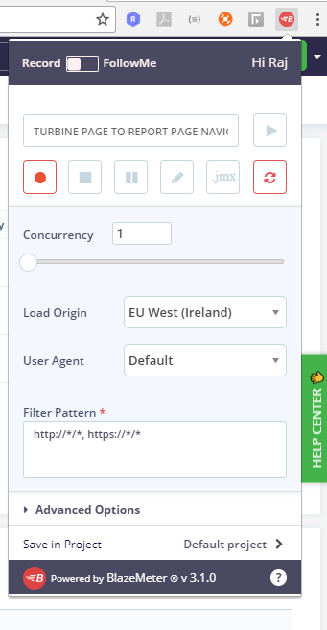

Steps for recording the scripts:

1. On extension of Blazemeter we can select the start button then we can navigate to the scenario which we want to capture.
2. On every click which all API’s are getting called are being recorded by Blazemeter tool.
3. Then we can select stop button to stop the recording of that scenario.
4. Now we can click on .jmx button to download those scripts.

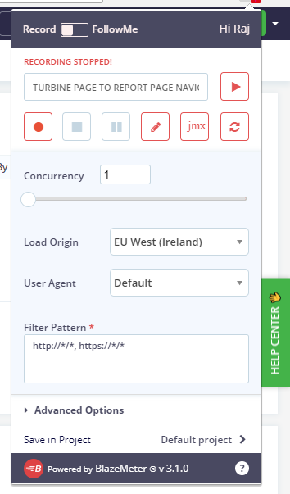

Executing the scripts :

1. We can import those scripts to Jmeter 2.13 and start testing for Number of users you want to test.
2. Add aggregate report and view report tree for checking average time of each threads being executed.

